Geospatial Intelligence and India’s Future Defence Edge
Prof. (Dr.) Y. Nithiyanandam

Byline:
Terrain is the first and oldest military intelligence layer. Mountains, deserts, valleys, rivers, forests, passes, and road networks decide how forces move, where they can sustain themselves, and where they are vulnerable.

Introduction
The purpose of intelligence is not merely to collect information. Its real value lies in reducing uncertainty for those who must make difficult decisions under pressure. In conflict, the side that understands terrain, movement, infrastructure, deception, logistics, and the adversary’s likely next step gains a clear advantage. This is where Geospatial Intelligence (GEOINT) becomes central to modern defence.
GEOINT is often misunderstood as a new name for imagery intelligence. That is a limiting view. Satellite imagery is important, and high-resolution imagery is becoming more valuable every day. But the modern battlespace cannot be understood only by looking at what is visible. Optical imagery tells us what the eye can see; GEOINT must also ask what is hidden, what is changing, what is connected, what is moving, and what may happen next.
This requires India to move beyond dependence on optical data alone. Radar imaging, infrared sensors, hyperspectral imaging, elevation models, Light Detection and Ranging (LiDAR), bathymetry, signals intelligence, human reporting, open-source information, navigation data, and field inputs must be integrated within a geographic framework. A location is never just a point on a map. It is linked to roads, rivers, bridges, tunnels, weather, elevation, settlements, communication lines, supply chains, and military choices. GEOINT brings these fragments together and turns them into intelligence that a commander can act on.

Lessons from Recent Conflicts
Recent conflicts have reinforced this lesson. Operation Sindoor showed the growing importance of precision, drones, air defence, electronic measures, surveillance, and real-time decision-making. The Russia-Ukraine war has shown how commercial satellite imagery, drones, radar data, open-source mapping, and battlefield sensors can shape operations as well as narratives. Conflicts in West Asia have highlighted the difficulties in finding hidden facilities, missile systems, and dual-use networks within civilian areas. Across these theatres, the message is clear: the future battlefield will reward those who can see beyond the visible picture.
For India, this is not abstract. It faces contested land borders, complex Himalayan terrain, a vast maritime domain, and persistent threats from terrorism, insurgency, and grey-zone activity. Defence intelligence cannot depend on disconnected inputs. It must move towards large-scale fusion, interpretation, and operational use at speed.

Reading the Terrain
Terrain is the first and oldest military intelligence layer. Mountains, deserts, valleys, rivers, forests, passes, and road networks decide how forces move, where they can sustain themselves, and where they are vulnerable. Along the Himalayan frontier, a road visible on satellite imagery may not necessarily support heavy military movement. A valley may appear accessible, but may be exposed to landslides, snow accumulation, flash floods, or adversary observation. A slope may look stable in one season and become hazardous in another.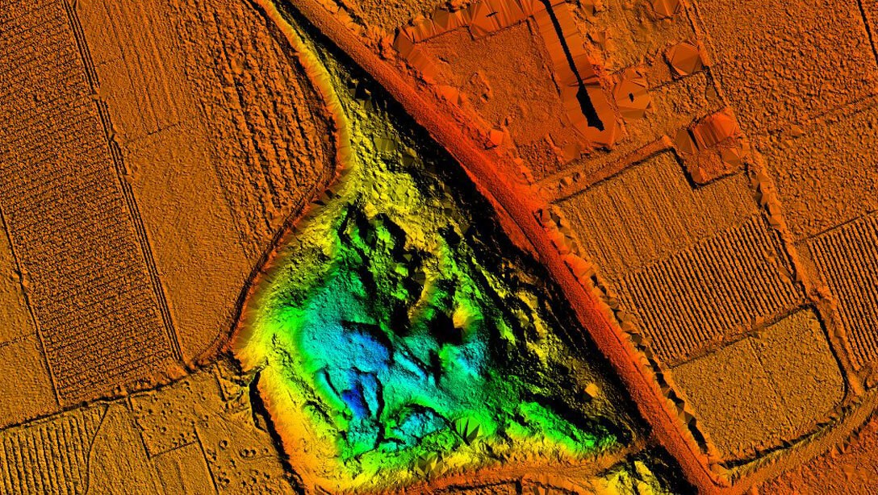
Terrain intelligence should combine satellite images, elevation maps, weather records, drainage patterns, soil conditions, road designs, field reports, and local insights. The same argument applies to patrolling routes along disputed borders. In many areas, the debate is not only about where a line lies on a map, but about how a route is accessed, used, obstructed, observed, and sustained. Three-dimensional mapping of patrol routes using LiDAR can create a more objective record of the terrain. Such datasets can support operational planning, reduce ambiguity on the ground, and provide stronger evidence in future discussions on patrolling routes, access patterns, and contested terrain.

Seeing the Hidden
Today, camouflage, concealment, decoys, and deception are standard in military planning. India’s 1998 Pokhran nuclear tests showed that timing and hiding operations can complicate outside observation. Although it is harder now with increased surveillance, if deception can outsmart visual observation, defence intelligence must expand its sensor range. Synthetic aperture radar can see through clouds and darkness, while thermal and hyperspectral data help identify heat patterns and intrinsic surface properties. The real value comes from combining multiple sensors over time rather than relying on a single source.
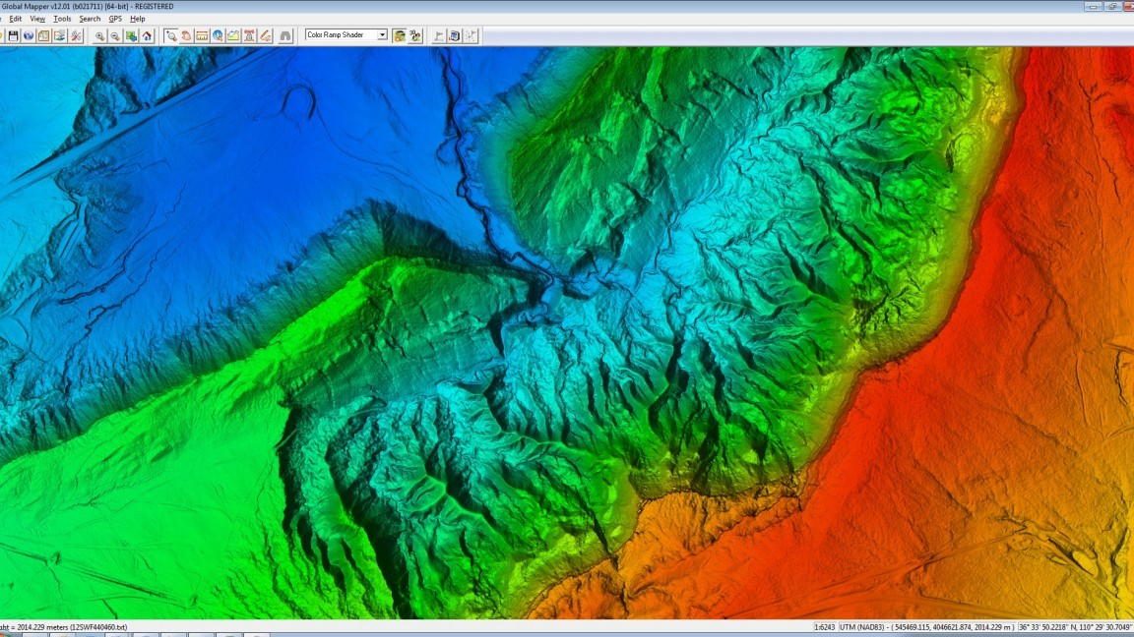
This is especially important for underground facilities, where clues such as tunnel entrances, vehicle movement, or changes in heat must be read alongside geophysical and communication data. The same logic applies to mobile targets such as missile launchers and insurgent groups, which are best tracked by patterns in movement, signals, and supply activity. In counter-terrorism and counter-insurgency, even partial geographic framing can reveal routes and hideouts. The aim is to shorten the gap between detection and response.
The Maritime Frontier
India’s maritime domain demands equal importance. The Indian Ocean Region is central to trade, energy flows, naval movement, undersea cables, and national security. It is also crowded with merchant ships, fishing vessels, dhows, and small craft. Among them may be smugglers, infiltrators, intelligence collectors, or hostile actors. The 2008 Mumbai attacks remain a sharp reminder that small vessels can create strategic consequences when maritime surveillance fails. Similarly, Iran used small boats to create uncertainty in a narrow strait.
Maritime GEOINT must combine coastal radar, satellite imagery, radar satellites, Automatic Identification System (AIS) data, electronic intelligence, port records, fishing patterns, and human reporting. AIS is useful, but not sufficient. Ships can switch it off, manipulate identity, or operate as dark vessels. Radar satellites can help detect vessels even at night or through cloud cover. Pattern analysis can identify suspicious loitering, abnormal routing, identity changes, or coordinated movement. Below the surface, bathymetry is equally important for submarine operations, mine warfare, underwater cable protection, and anti-submarine planning.

Pushing GEOINT to the Front Line
India already has advanced capabilities in several defence, intelligence, space, and technical units. Sophisticated use of high-resolution satellite data, Geographic Information Systems (GIS), sensor inputs, maritime tracking, and operational intelligence is already underway. The issue, therefore, is not absence. It is scale, integration, and last-mile operationalisation. Given India’s geography and threat environment, GEOINT must not remain confined to select specialist cells. It must increasingly reach lower levels of deployment, each at the level of detail its mission requires
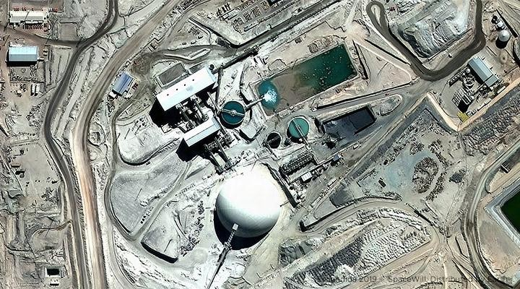
A forward commander does not always need a complex national-level product, but rather a reliable, up-to-date, and operationally relevant picture of terrain, routes, obstacles, adversary activity, weather, settlements, communications, and likely risks in the area of interest. A battalion-level unit in the mountains, a coastal security unit in a fishing belt, or a formation monitoring drone activity near the border can gain enormous value from simplified but accurate geospatial intelligence products. This demands training, policy, secure data access, and user-friendly systems.

The Case for Sovereign Capability
India must also be cautious about over-dependence on earth observation datasets, especially when some of the finest commercial datasets come from non-Indian sources. Recent geopolitical developments have shown that access to commercial imagery can be delayed, restricted, or shaped by political considerations. This is a serious lesson. In a crisis, India cannot afford to depend on external data pipelines for its most sensitive operational requirements.
A high-resolution image does not automatically yield sharper intelligence. A camouflaged structure, disturbed soil, underground facility, or civilian-looking logistics node rarely reveals its purpose through optical imagery alone; the answer usually comes from repeated observation across the electromagnetic spectrum, fused with other Earth observation and GEOINT datasets, many of them in the open domain.
Current and planned national space-based surveillance programmes can help minimise this gap. Still, they must be treated as part of a sustained national capability, not as a one-time satellite expansion. India needs more indigenous payloads across optical, radar, infrared, hyperspectral, electronic, and maritime surveillance domains. Revisit frequency, sovereign tasking, assured access, secure processing, and rapid dissemination are as important as spatial resolution. The question is not merely how clearly India can see, but how consistently, independently, and intelligently it can interpret what it sees.

Machines Alert, Analysts Decide
Artificial intelligence is already reshaping how GEOINT is produced, and its geospatial branch, GeoAI, is maturing quickly. It deserves institutional recognition rather than project-level enthusiasm. It deserves institutional recognition, not just project-level enthusiasm. Rather than having analysts manually screen thousands of square kilometres for new roads, shelters, tunnels, missile sites, or vessel movement, GeoAI can detect change, classify objects, flag abnormal activity, and narrow the search to what genuinely needs human attention. But these systems must be built around Indian terrain, operational needs, and security concerns.
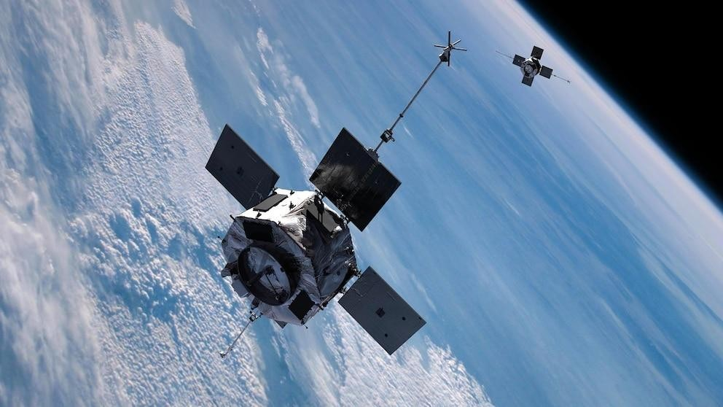
A model trained elsewhere will not read context the way the situation demands: a road in the Himalayas, a shed near a missile site, a fishing vessel off the coast, or a truck near a tunnel can each mean very different things depending on where and when they appear. Machines can alert. Analysts must interpret. Commanders must decide. In defence applications, that distinction is vital.

An Architecture for Integrated GEOINT
The challenge ahead is also conceptual. Modern military threats do not always appear in conventional military form. A road may serve both civilians and soldiers. A warehouse may support trade and mobilisation. A village may be both a settlement and a forward logistics node. A port, tunnel, helipad, airstrip, or renewable energy buildup may carry dual-use significance. If intelligence focuses only on visible military objects, it will miss the broader network that enables military action. GEOINT must therefore understand not only targets but also systems, connections, patterns, and intent.
India needs an institutional architecture for integrated GEOINT. Different organisations hold different parts of the intelligence picture: satellite imagery, signals, maritime data, border reports, terrain datasets, open-source material, and field intelligence. These must not remain locked in silos. Security and compartmentalisation are necessary, but decision-makers need integrated assessments, not disconnected reports.
Capacity building is equally important. India needs GEOINT professionals who grasp the physics of remote sensing, the architecture of GIS, and the realities of terrain, sensors, military geography, and adversary behaviour. Just as important, academic and industry research must build an ecosystem for developing new algorithms, not merely applications layered on existing ones. None of this comes from software training alone; it requires sustained education, military exercises, simulation, and collaboration among the armed forces, scientific institutions, industry, universities, and policy communities.
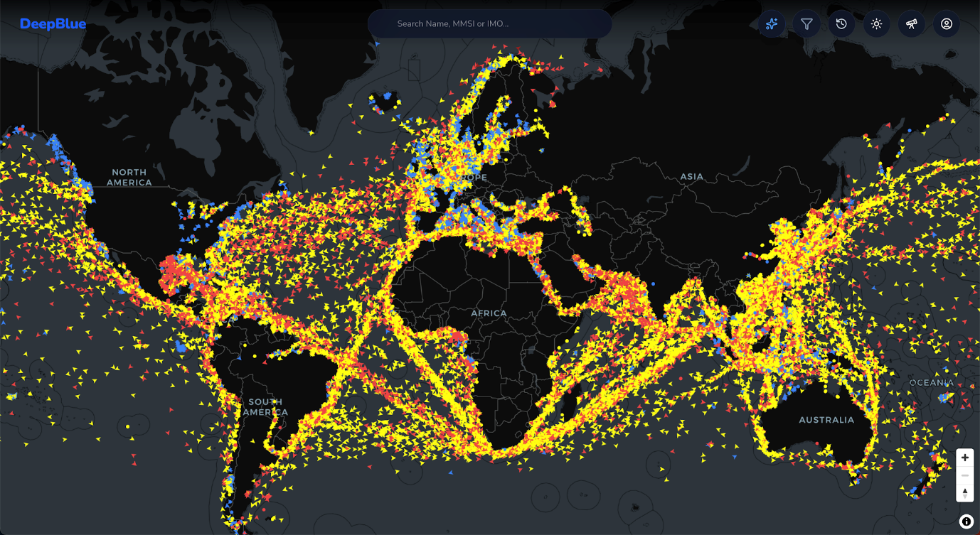

Conclusion
GEOINT must move from being a support function to becoming a core intelligence capability, scaled across institutions and pushed to the lowest meaningful level of deployment. The decisive edge will not come from any single sensor, however sharp, but from fusing every sensing modality, optical, infrared, radar, and hyperspectral, with the full range of intelligence disciplines and products: terrain, maritime, signals, human, and open source. High spatial resolution shows what there is; fusion explains what it means. In future warfare, geography will not merely describe the battlefield. It will decide who understands it first, who acts with confidence, and who holds the advantage.

